**City University London**

**BSc Computer Science with Games Tech**

**Advanced Games Technology**

**IN3026**

**Game Documentation**

**By Tadas Vaisvila**

1. **Project Overview:**

Title: Cow Chase

Theme: Apocalyptic

Genre: Arcade

Description: The player controls a robot in foggy surroundings and tries to catch a cow to get points. Every time the player scores, cow runs away forcing a player to go and chase after it. Player is being continuously chased by a wolf and if the player fails to run away, they lose one of their three lives.

Controls:

WASD – Move around

E – Interact

Spacebar – Jump

Testing controls:

H- Decrease health

P – Increase points

NUM 5 – Toggle fog

All assets are royalty free unless stated otherwise

**List of assets used:**

1. **Sound:**

* Sound effects from soundbible.com

‘Hard shoes sound’ by Daniel Simion

Under CC Attribution 3.0 license.

Date of download: 2019/11/27

‘Jump’ by snottyboy

Under CC Attribution 3.0 license.

Date of download: 2019/11/27

* Music from <http://dig.ccmixter.org/games>

Plastic Motions by Stefan

Under CC Attribution 3.0 license.

Date of download: 2019/11/26

1. **Meshes:**

* From a given template:

Mannequin

Cow

Tree

* Wolf 3D Model <https://free3d.com/>

Wolf by 3dhaupt

Under Personal Use License

Date of download: 2019/11/20

* Stone Well 3D Model <https://free3d.com/3d-model/stone-well-34248.html>

By shadedancer619

Under Personal Use License

Date of download: 2019/11/20

* Truck 3D Model <https://www.turbosquid.com/3d-models/weathered-truck-ruins-obj-free/668299>

Truck by ERLHN

Under TurboSquid Royalty Free License.

Date of download: 2019/10/14

* Logs 3D Model <https://free3d.com/3d-model/roundwood-41562.html>

Logs by gunnarcorrea

Under Personal Use License

Date of download: 2019/11/21

1. **Textures:**

* Skybox from <http://www.petesoasis.com>

Skybox by The Mighty Pete

Under GNU General Public License version 2.

Date of download: 2019/10/17

* Sand texture from <https://www.creativeswall.com/30-free-sand-textures/>

Sand Texture by mameara

Under GNU General Public License version 2.

Date of download: 2019/10/17

* Rock texture from <https://www.turbosquid.com/FullPreview/Index.cfm/ID/371843>

Stone 1 by MedievalWorkshop

Under Turbosquid Royalty Free License

Date of download: 2019/11/25

* Rusty metal texture from <https://www.texturepalace.com/download-rusty-metal-texture/>

Rusty Metal Texture by Szabolcs

Date of download: 2019/10/19

* Intro picture with controls created by me using GIMP 2.0 by using default text tool and changing text colour afterwards.

No additional libraries were used.

1. **Implemented features:**

* Intro screen with keyboard/mouse controls:

I have drawn a quad on a screen which I used to display an image on and used cross_fade class to make it fade after correct input is made and reveal the game.

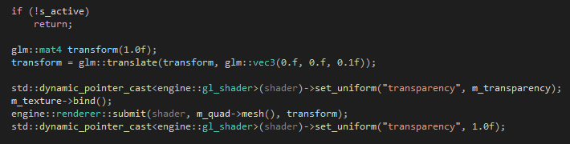

* Objects using OpenGL primitives:

I have made a shape that resembles a spaceship and a rock by using vertices and normals. After that I applied SoRT to place them correctly within a world

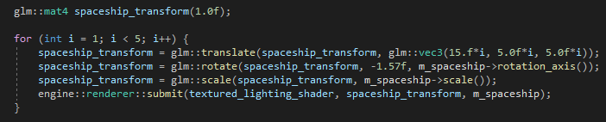

* Audio:
* Head’s up display:

I have used a 2D Text Shader from Shaders library to draw HUD on top of the game view so player could see how many lives they have left and what is their score.

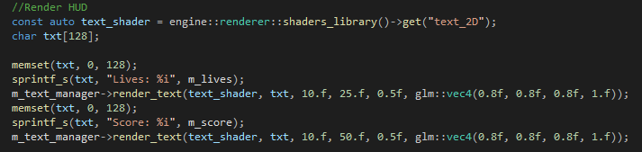

* Camera motion technique:

I have implemented a 3rd person view for my game as I think it suits the gameplay.

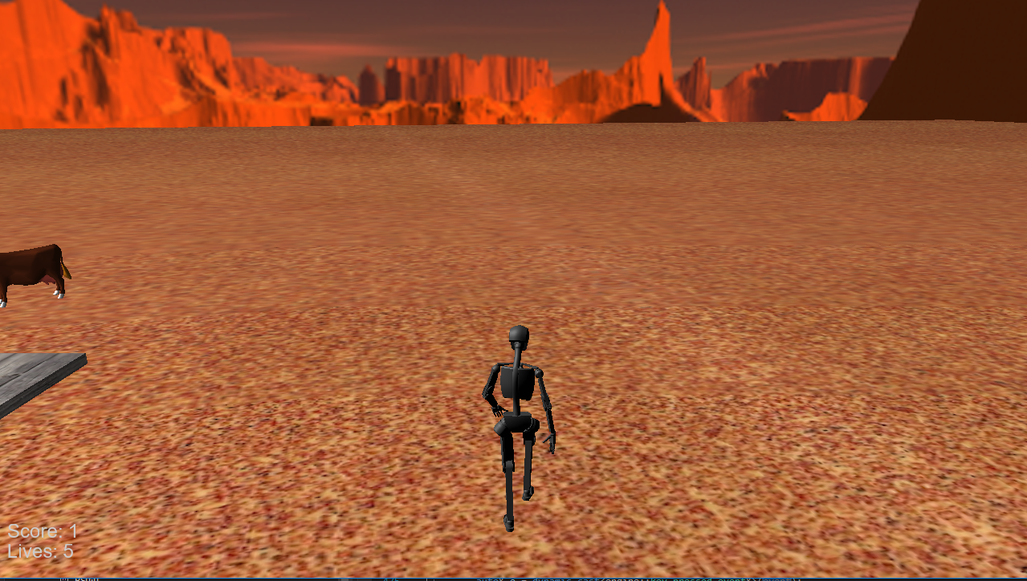

* Mesh based objects:

I have added well, truck and log stack objects into the game and applied sort to place them in a world correctly. NOTE: 1. Well mesh is missing textures on the inside and they were not included by the original creator.2. Log model is slightly clipping with the ground because the model has weird artifact on the bottom that I wanted to hide as I couldn’t manage to remove it with Blender.

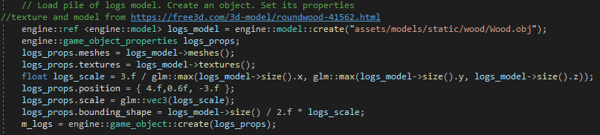

* Light and colour effects:

I have Implemented a point light that moves and acts as an alien spaceship. I am going to use it to switch levels when I have more than one. I have also used directional light, changed its location to make it look like it is evening time and changed its brightness diffuse level and ambience level. I have attempted to create directional light to use it as truck lights but I did not succeed due to not figuring out why I could not see them in the world.

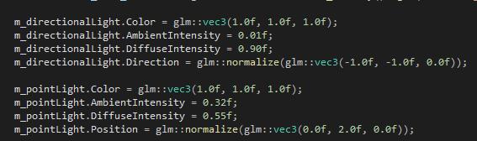

* Special effects:

I have implemented fog and cross fade to my game. The fog is used to make the game harder, so I implemented a way to get rid of it by pressing NUM 5 as it could get in a way when checking if everything works correctly. I use cross fade for my intro screen to make a nice fade effect.

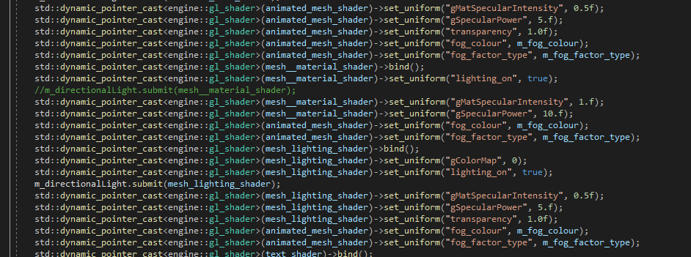

* Non-player characters:

As I have struggled to figure out how to use rigged meshes as a lot of them had all animations within one .dae file, I decided to use static objects as characters. I have created a simple AI for cow that runs away when player presses E key when they’re close by. The cow stops when It reaches a certain distance away from player. I have also attempted to implement a wolf that would chase a player to create sense of urgency but I could not get my mesh to work properly and decided to comment out the code for it.

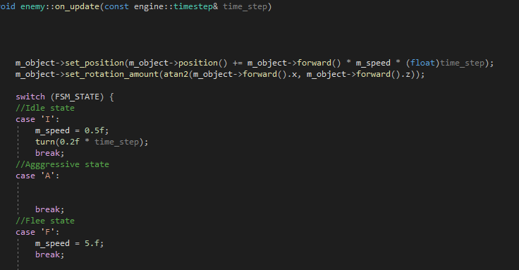

* Gameplay elements:

Player has ability to get a speed boost when they get close enough to the well. Player scores by catching a cow. Player loses health if they get attacked. Score and Lives can be tested by pressing P and H keys .



* Audio:

Added sound effects when player jumps and walks, changed background music. NOTE: In some cases I was experiencing a weird bug where some sounds were duplicating and overlapping each other after triggering them once so I decided to play and pause them immediately so they would be preloaded and using unpause() when I need them.

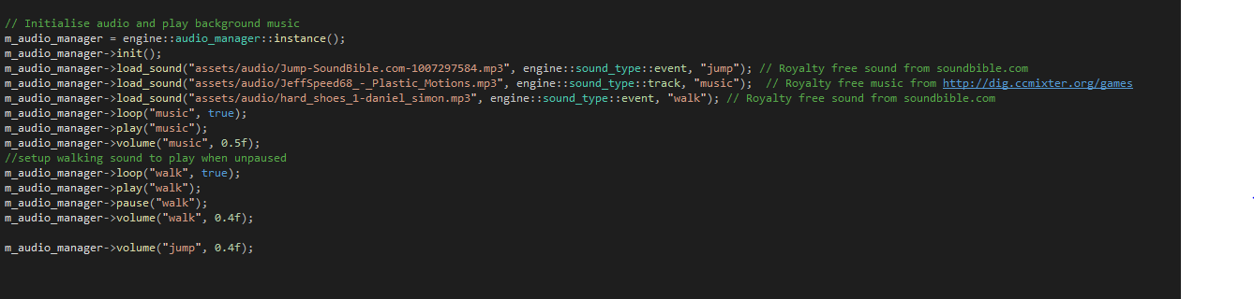

Not Implemented:

Game Physics.

Screenshots:

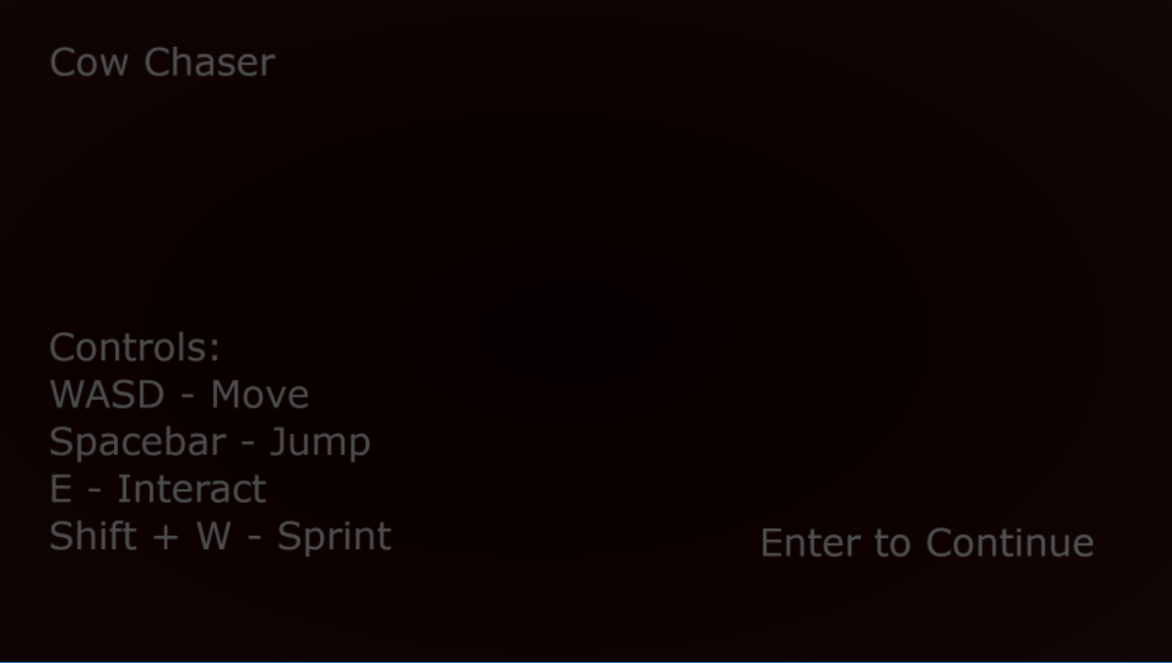

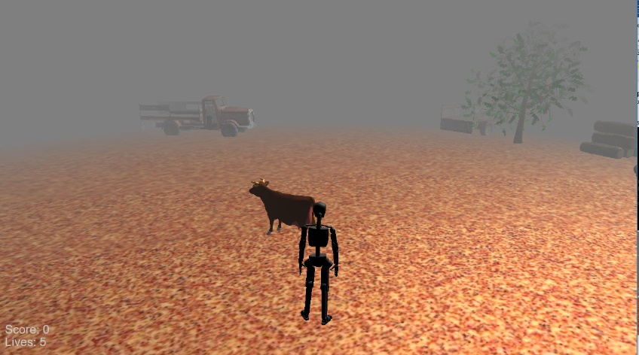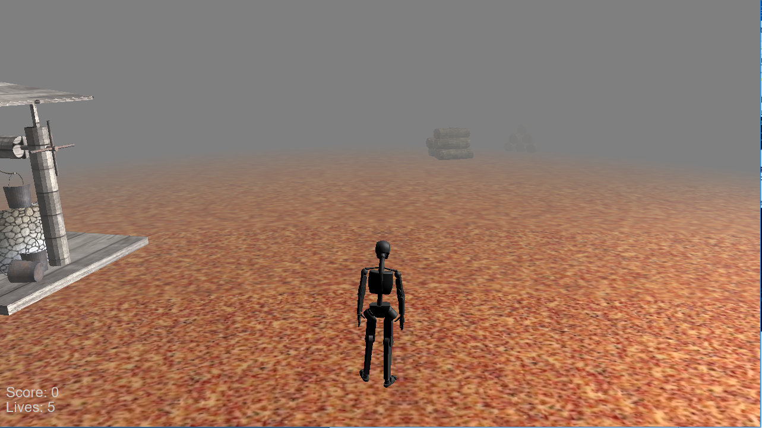

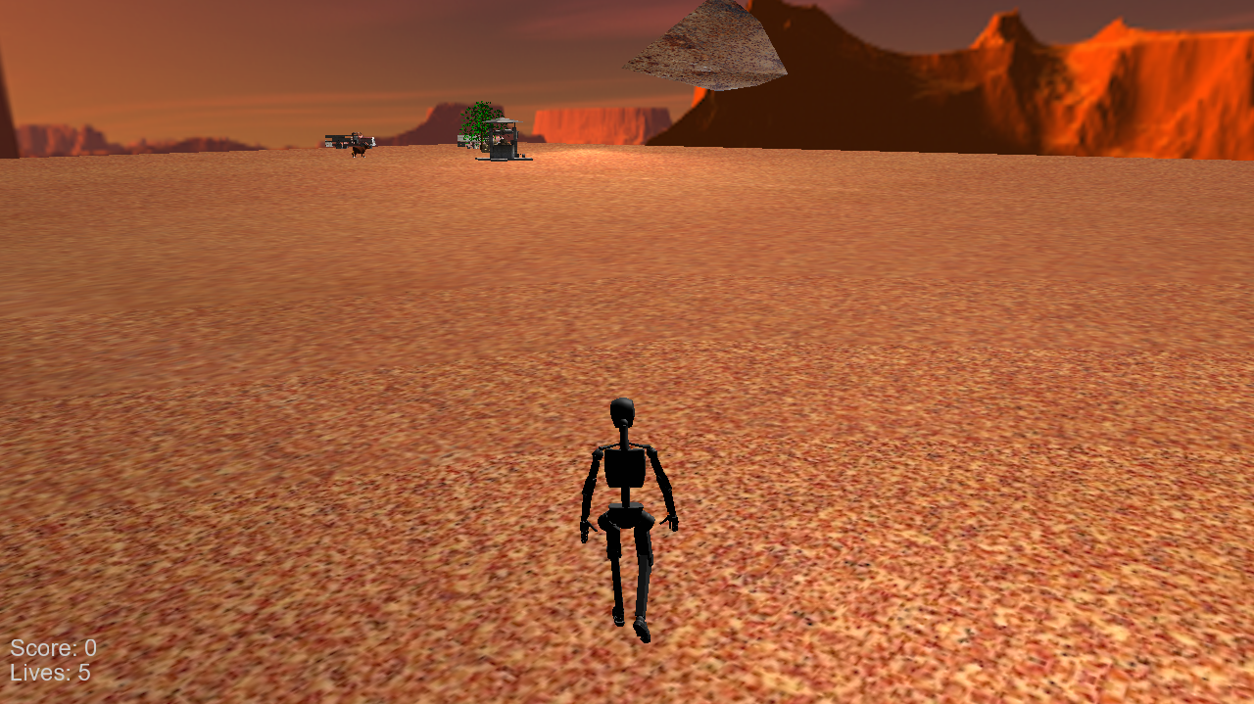

1. **Discussion:**

The greatest weakness of my project was a fact that I lack experience in game development so achieving what I set out for in milestone 1 was close to impossible.

I have struggled a lot when I had to create my own primitive based objects because I could not figure out how to create any partially rounded shapes or any shapes that would be usable in a real scenario. My lack of experience using software like Blender lead to problems when trying to use animated 3D models as a lot of creators put all their animations in a single file which is not ideal for this assignment. I believe I could have done a better job if I had more time and I will most likely continue working to make this project a fully playable game.

Although I have encountered a lot of problems while working on this project, I have learnt a lot as well. I have gained quite a lot of experience with OpenGL and asset implementation in games. This has also motivated me to keep working on games development as it rather challenging but also very enjoyable.